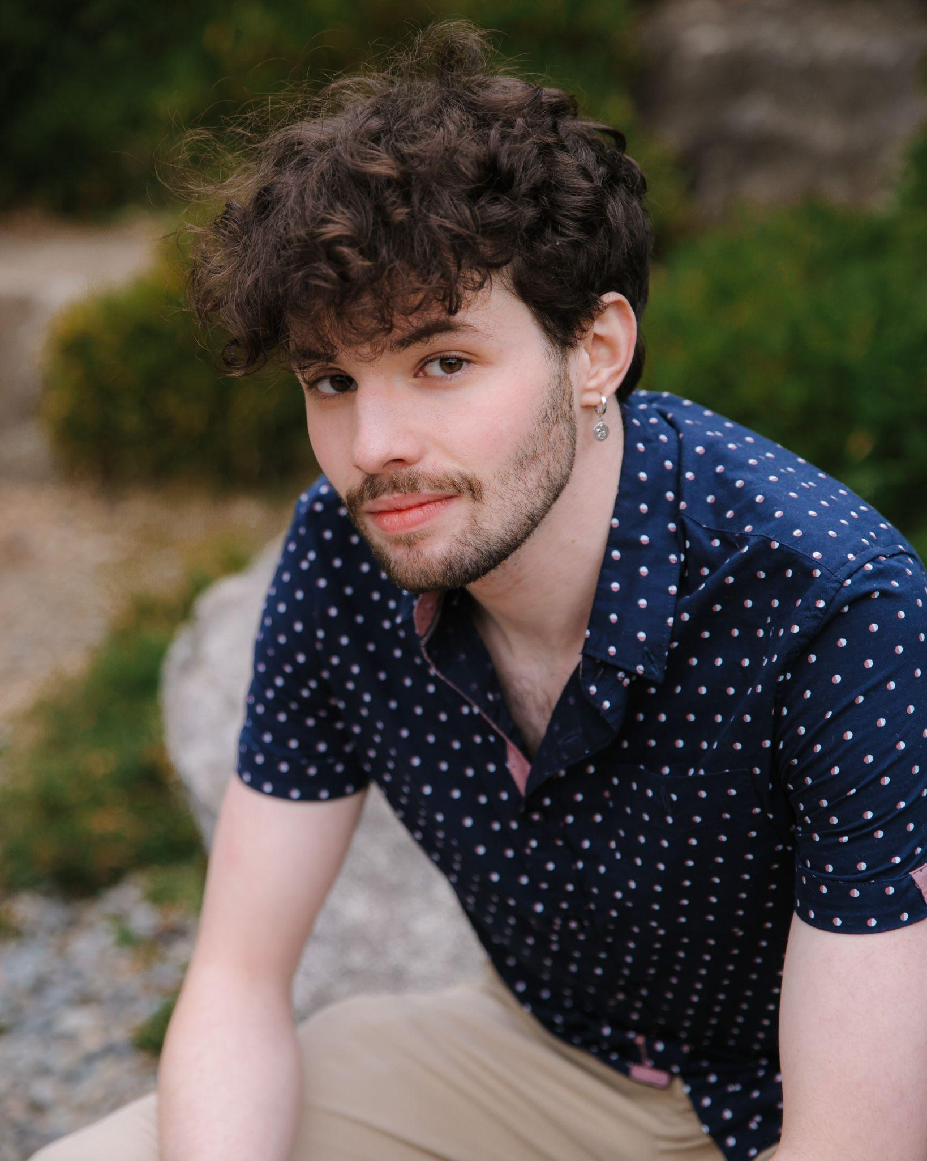Sam Neer

[samneeracting@gmail.com](mailto:samneeracting@gmail.com)

(206) 613-9384

samneer.com

Height 5’8”

Weight 140 lbs

Eyes brown

Hair brown

Open to changing appearance for roles

**Film:**

## Tony Abreu’s Devilish Swing, Tony Abreu Music — *Skeleton*

Featured

## In The Summer Rain, Petracore Collective — *John*

Supporting

## Beast of Aberdeen, Dir. Ryan McGeary — *Sid*

Lead

**Mudmen (post production),** Seattle Art Museum — *Darren*

Lead

## Just Friends (post production), Honeycomb Productions — *Isaac*

Lead

## Embrace (post production), Rushjob Productions — *Aaron*

Lead

**Theatre:**

## Mississippi Summer, Seattle Jewish Theatre Company — *Steve Leibowitz*

Lead

## The Mousetrap, Edmonds Driftwood Players — *Giles Ralston*

Supporting

## A Midsummer Night’s Dream, UW Undergraduate Theatre Society — *Theseus*

Supporting

## Savage in Limbo, UW Undergraduate Theatre Society — *Murk*

Supporting

**Education:**

University of Washington - BA Drama: Performance

**Accents:**

Midcentury Mahattan, English RP